User Guide: Getting Started 🛒
Welcome to the Smart Shopping Checklist! Here is your guide to getting the most out of the app.

0. Status Indicators (Top Right)
At the top of the app, you will find three status LEDs. They show you in real-time whether everything is working correctly:
- MQTT (Broker Connection):
  - 🟢 Green: Connected! The communication with the server is active.
  - 🔴 Red: No connection to the broker. Please check your credentials or your Wi-Fi.
- DATA (Data loaded):
  - 🟢 Green: Catalog and settings successfully loaded.
  - 🔴 Red: Data could not be loaded. Please reload the page.
- SYNC (Synchronization):
  - 🟢 Green: Everything is synced.
  - 🟠 Orange: Transmission in progress (saving).
  - 🔴 Red: Transmission error. Please try again briefly.

1. Login (Authentication)
This is your access to the app. Please use your personal MQTT username and password.
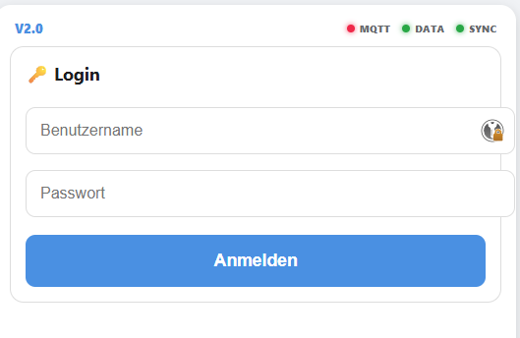

- Important: Every family member needs their own individual account. This is the only way the app can track who added an item and when it was added.
- Persistence: The app saves your credentials, so you do not need to log in every single time.

2. Planning
This is where you add new items to the list.
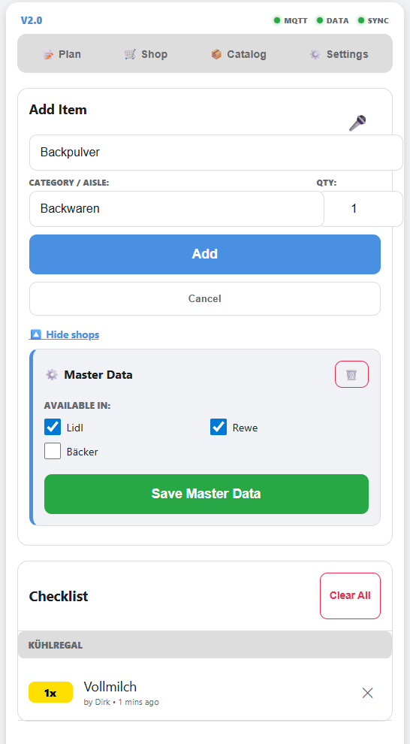
- Tip: Use the 🎤 button for quick voice input!
- Categories: Every item should be assigned a category. Unassigned items will appear in the "⚠️ Assign category!" list.

3. Shopping
This is where you check off items together.
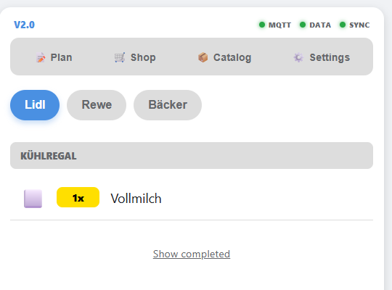
- Routes: The list sorts itself automatically based on the settings you defined for each specific store.
- Real-Time: As soon as someone checks off an item, it disappears for everyone else in real-time.

4. Management
Use this section to maintain your system.
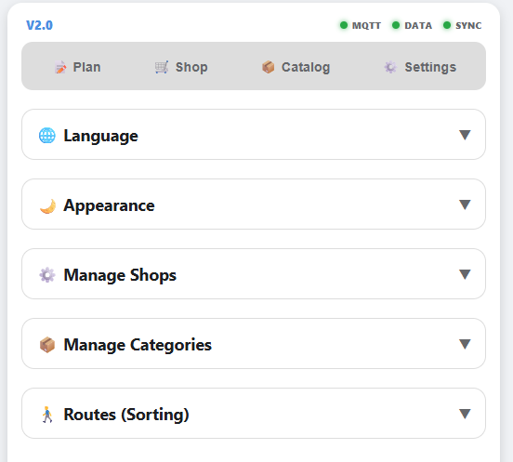
- Categories: Here you can rename aisles or move individual products.
- Routes: Define the perfect order of aisles so you don't have to walk back and forth through the store.

